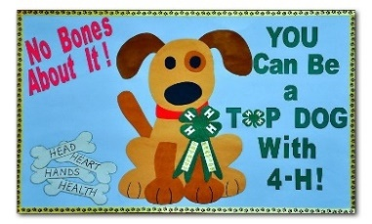
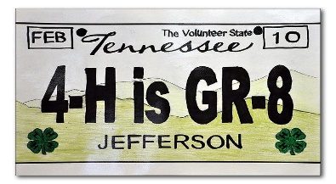

4-H Poster Contest
Posters are a form of visual communication. That means you are using words, pictures, or symbols to get your message or idea across. Competing in the 4-H Poster Contest gives you a chance to practice this skill and have fun being creative. You can draw, paint, use cut-outs, or graphics to create your own 4-H message.

- Poster size should be 14x22 inches (1/2 sheet of poster board) and drawn horizontal.
- Your poster must promote 4-H.
22”

14”
Horizontal
- Make sure you have a 4-H Clover on it.
- Do not use well-known cartoon characters, name brands or other copyrighted materials. All ideas, symbols and logos must be original.
- Choose a catchy slogan or idea.
- Make your artwork relate to your slogan.
- If you decide to make your poster 3-dimensional, items put on the poster must NOT be any thicker than a dime.
- On the back of your poster, write your first and last name, grade, teacher‛s name, school, and county.
(Do NOT Copy the above posters and turn them in as your own.)
- DO NOT use foam boards. Posters must be able to roll up.
- If you have any questions, please call the UT Extension Office at 423-346-3000.

Helpful Hints:
  - Make it colorful and eye-catching.
  - Make sure it is easy to read (lettering is large enough to be read at a distance, contrasting colors, etc.).
  - Use simple lettering that is easy to read.

Programs in agriculture and natural resources, 4-H youth development, family and consumer sciences, and resource development. University of Tennessee Institute of Agriculture, U.S. Department of
Agriculture and county governments cooperating. UT Extension provides equal opportunities in programs and employment.

